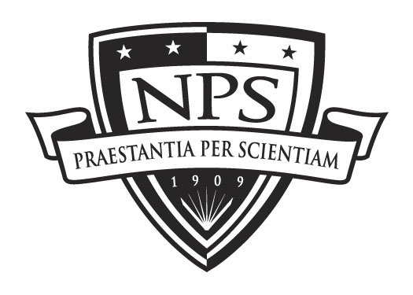
DL Student Check-Out Sheet
Privacy Act Information
rules apply.
Naval Postgraduate School

Name Steve Mazza Civilian Military Contractor

Rank Military Branch Army Location/Command APG

Curriculum Code: 311
Check: GSBPP SIGS GSOIS GSEAS

Notes: Complete All Steps for Graduation

Step I – All Students: MANDATORY Completed: SM
Update Python Student Initials
* SEE Reverse Side of this sheet for info to be entered in PYTHON -- Complete before Check-Out or your diploma will be delayed.

Step II – All Students Completed: SM
Library - Circulation Desk See back of form Student Initials

Step III – If Applicable Completed: N/A
Equipment Return Student Initials or N/A
CED3 Student Coordinator Contact: Nikki Brink Knox Library KN-154 831-656-7850
Naval Postgraduate School Lab Equipment
Educational Design, Development, and Distribution Mindstorm Kit
411 Dyer Rd., Bldg 339, Room 154 Headset
Monterey, CA 93943 Webcam

Step IV – OPTIONAL Completed: N/A
Public Affairs Office Herrmann Hall HE-130 Student Initials or N/A
- Complete HOMETOWN NEWS RELEASE & turn in 831-656-3164

Step V – Student Thesis/Capstone Completion Completed: SM
Education Technician – Check out with your Ed Tech Student Initials or N/A
SE DL Ed Tech 585-309-4163
Ed Tech Must have all the following documents electronically:
Signed Thesis Signature Page
Signed Thesis Release Form
Final Copy of Thesis (word & pdf format)
Special Abstract
Certificate of Thesis Completion (Green Card)
**Your Green Card will be issued to you once your thesis has been cleared by a thesis processor for formatting and approved by all pertinent parties**

Step VI – Students Requiring a Thesis Extension (PD21)
Education Technician – Check out with your Ed Tech Completed: N/A
SE DL Ed Tech Student Initials or N/A
Make sure Ed Tech has the following document electronically: 585-309-4163
Signed Thesis Extension Form (to be Forwarded to Registrar)

**Remember, once you graduate, your NT account will remain active for 30 days only. Filing a thesis extension will extend your NT account accordingly**

Step VII – All Students Completed: SM
Departmental Checkout – Complete the following AND follow steps on the back of this sheet Student Initials or N/A
SE DL Ed Tech 585-309-4163

1. Confirm & Provide Thesis/Diploma/Certificate Mailing Address

Name: Steve Mazza

Address: 423 Gilmor Road

City/State/Zip: Joppa, MD 21085

2. Forwarding Contact Information

Cell Phone: 410-322-6166

Email (other than NPS email): spmazza@gmail.com

3. Check if you want your information forwarded to the NPS Alumni Society

GRADUATING???
The following must be completed BEFORE 6/21/13:

1. Complete the following in PYTHON:
a) On your (gray) permissions bar (left of screen), click Menu, followed by My Profile, followed by Family Members:
- click on ADD ADDRESS
- select: Thesis/Diploma/Certificate Mailing
  - select: OTHER
  - Enter your diploma mailing ADDRESS
- Enter EMAIL address you will be using once your NPS email account (@nps.edu) expires (in the event we need to contact you after you’ve departed, email will be our preferred method of contact)

b) On your (gray) permissions bar (left of screen), click on Student Folio, followed by My Matrix
    - select: the Student_Information tab and add the following information:
    - click on Diploma Name Format: enter your name as you want to see printed on your DIPLOMA (same as you indicated to your Ed Tech ), click Update
    - click on Thesis Information (721 students only):
      - enter your Thesis title in the appropriate box, click Update

Library Checkout Procedure:

Your Library record indicates that you will graduate and/or leave the Naval Postgraduate School (NPS) this quarter.
As you may know, out processing includes clearing your account with the Dudley Knox Library. To see a list of items currently checked out to your account, from our Library homepage http://www.nps.edu/Library/ click on Search BOSUN Catalog. Once in BOSUN, click on My Account in the gray bar, then click on Review My Account and login with your User Name (remember to use ALL CAPS) and Library Password. Items must be returned before your account can be cleared.
We would like to take this opportunity to remind you that the Dudley Knox Library and the NPS Alumni Relations Office have partnered on a Pilot Project to provide registered alumni from degree granting NPS programs with access to a select group of licensed scholarly information resources 24 hours a day / 7 days a week. Please visit our Alumni Access webpage for additional information and to register: http://libguides.nps.edu/Alumni.
If you will not be leaving NPS this quarter, please contact the Circulation Desk so that we can update your Library record: email circdesk@nps.edu phone (831) 656-2947, or stop by the Circulation Desk.
Thank you for your cooperation. We wish you the very best as you move on to your next assignment.
Sincerely,
Circulation & Interlibrary Loan Services
circdesk@nps.edu; ill@nps.edu

